- Waste report:
Job # (job.job-no, job.job-no2)
Job close day (job.close-date)
Customer (job-hdr.cust-no)
Qty produced at each machine for that job (mch-act.qty) JQ1 MachQty Tab
Waste reported (mch-act.waste)
Table Joins:
Job table
job.company = company code (for example 001)
job.job-no = job-number
job.job-no2 = job-sub number
Job-Hdr table (record for each sheet and blank and the job)
job-hdr.company = = company code (for example 001)
job-hdr.job-no = job.job-no
job-hdr.job-no2 = job.job-no2
Mch-Act table (each machine on the job has its own record)
mch-act.company = = company code (for example 001)
mch-act.job = job.job

- Closed jobs analysis:

Job# (job-hdr.job-no and job-hdr.job-no2)
Job Qty (job-hdr.qty)
Customer (job-hdr.cust-no)
Qty Produced at each machine for that job (mch-act.qty)

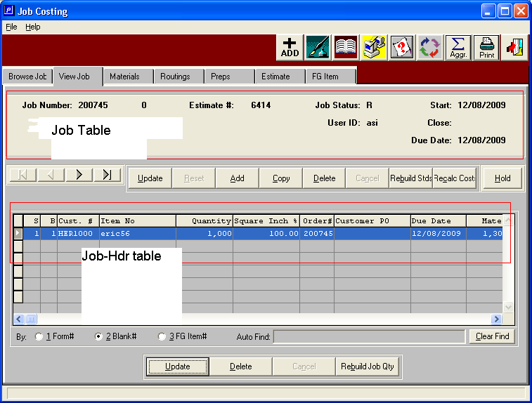

JR5
Here is some code that shows how the quantity produced field is calculated:

Work-item.qty-prod is a temporary field used in report used to keep track of the quantity produced.

Itemfg.company = company code
Itemfg.i-no = job-hdr.i-no
IF itemfg.isaset AND itemfg.alloc THEN
FOR EACH fg-act
WHERE fg-act.company eq job-hdr.company
AND fg-act.job-no eq job-hdr.job-no
AND fg-act.job-no2 eq job-hdr.job-no2
AND fg-act.i-no eq job-hdr.i-no:
work-item.qty-prod = work-item.qty-prod + fg-act.qty.
END.

/*Posted finished good receipts*/
FOR EACH fg-rcpth
WHERE fg-rcpth.company EQ job-hdr.company
AND fg-rcpth.i-no EQ job-hdr.i-no
AND fg-rcpth.job-no EQ job-hdr.job-no
AND fg-rcpth.job-no2 EQ job-hdr.job-no2
AND fg-rcpth.rita-code EQ "R",

EACH fg-rdtlh NO-LOCK
WHERE fg-rdtlh.r-no EQ fg-rcpth.r-no
AND fg-rdtlh.rita-code EQ fg-rcpth.rita-code:

work-item.qty-prod = work-item.qty-prod + fg-rdtlh.qty.
END.
Selling Price – Sum of oe-ordl.t-price for that item
oe-ordl.t-price
Oe-ordl.company = company-code
Oe-ordl.job-no = job-hdr.job-no
Oe-ordl.job-no2 = job-hdr.job-no2
Oe-ordl.ord-no = job-hdr.ord-no
Oe-ordl.i-no = job-hdr.i-no
Quantity Ordered – Some of oe-ordlqty for that item
oe-ordl.qty
Oe-ordl.company = company-code
Oe-ordl.job-no = job-hdr.job-no
Oe-ordl.job-no2 = job-hdr.job-no2
Oe-ordl.ord-no = job-hdr.ord-no
Oe-ordl.i-no = job-hdr.i-no

